Daily Events/ Activities conducted in the Departments
S.No. | : | 1
Name of the Department | : | Heritage club
Name of the Activity | : | National Tourism Day
Resource person | : | Sri.B.Venkateswarlu District Tourism Officer and Dr. M.Indira Santhi garu Principal
Date conducted | : | 25-01-2022
Photo | : | 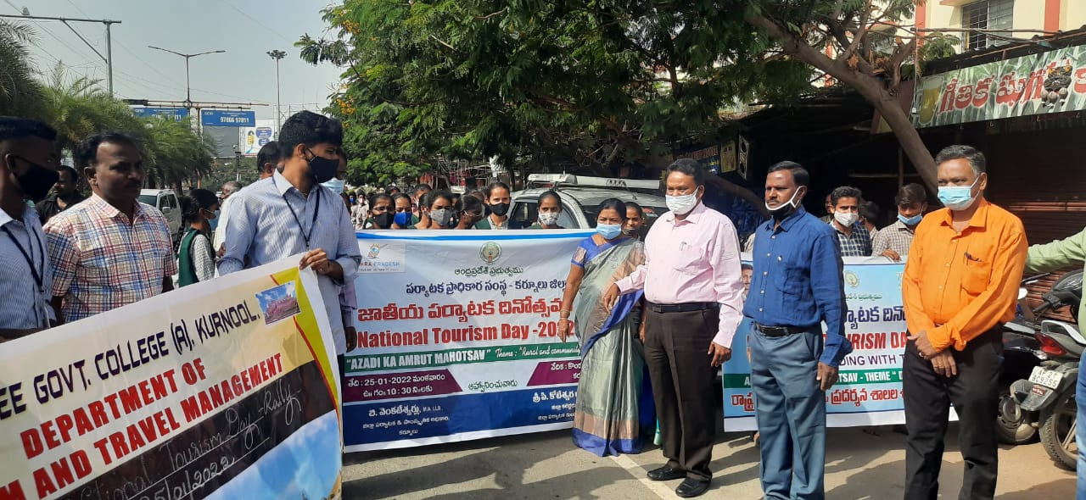  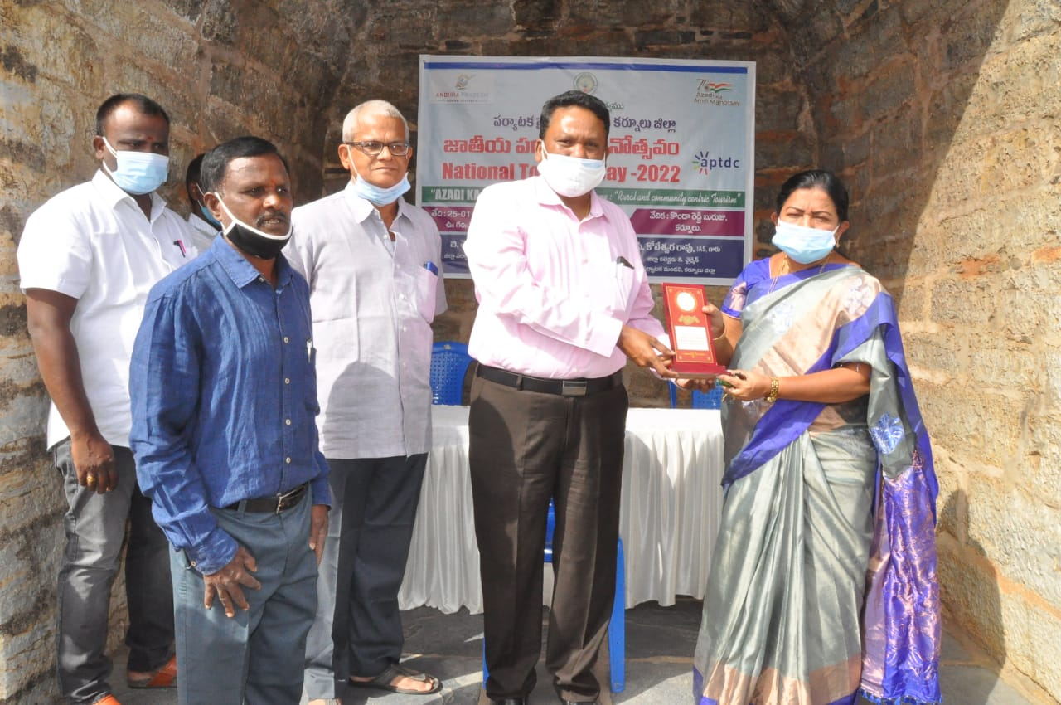
Brief report about activity | : | The National Tourism Day was Celebrated by Heritage club on 25-01-2022 to appreciate India’s beauty and spread awareness about the importance of Tourism and its impact on the Economy. A rally was organized by the principal Dr. M. Indira Santhi and Heritage club members from the college to Konda Reddy Buruju in collaboration with the Dept of Tourism and culture on this day. The students of the college also participated in this event. The District Tourism Officer  Sri. B. Venkateswarlu organized the whole event.

